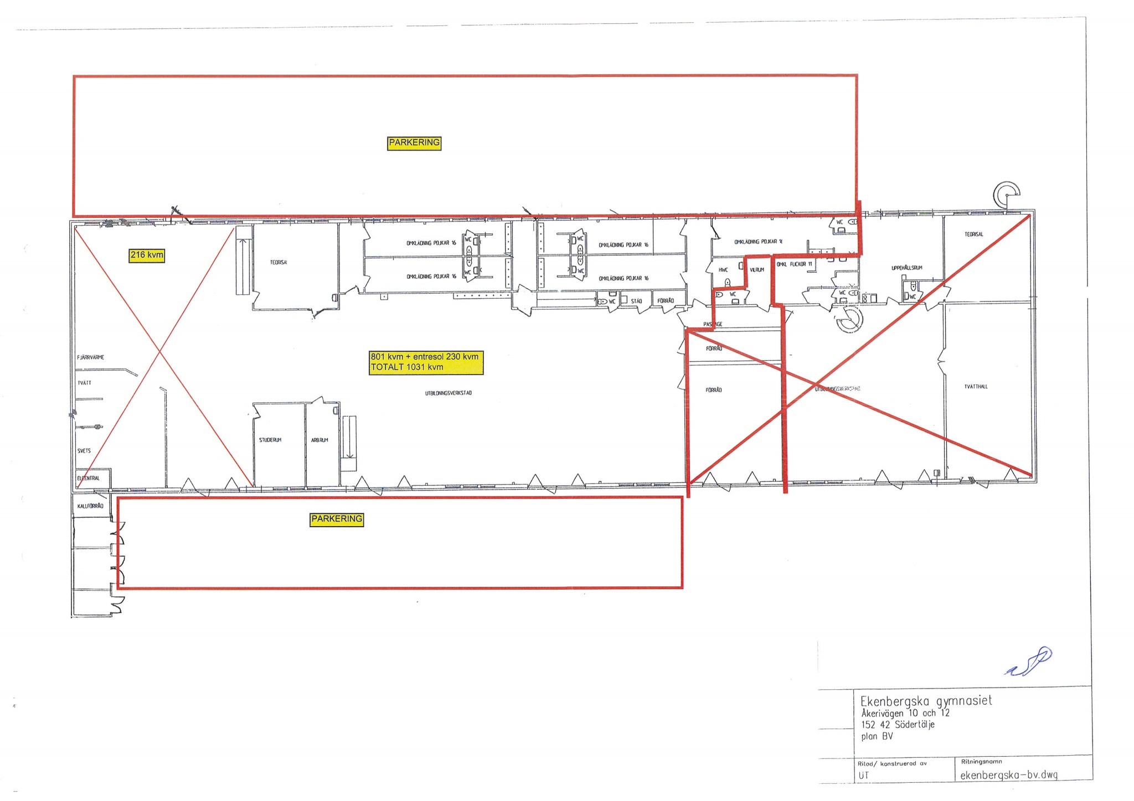

**Alternativ 1.   
450 m2 markplan + 111 m2 entresol**